Homework # 8 – Mann-Whitney Test Tutorial on SPSS for Windows

Raw Data:
Exp. Group: 11.9, 11.7, 9.5, 9.4, 8.7, 8.2, 7.7, 7.4, 7.4, 7.1, 6.9, 6.8, 6.3, 5.0, 4.2, 4.1, 2.2
Control Group: 6.6, 5.8, 5.4, 5.1, 5.0, 4.3, 3.9, 3.3, 2.4, 1.7

Hypotheses:
- The null hypothesis H_{o,} is that the median scores of the two groups will not differ
- The alternative hypothesis H_{a}, is that the median scores of the two groups will differ

Data in SPSS:

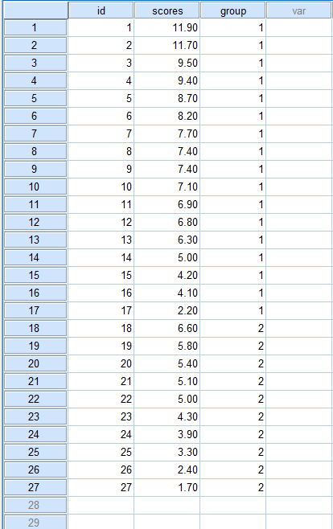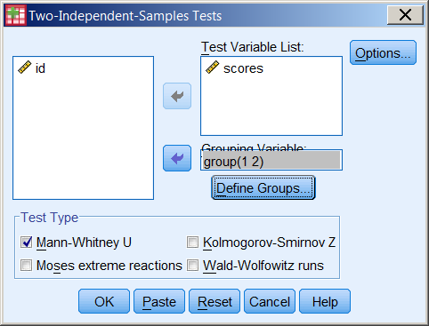

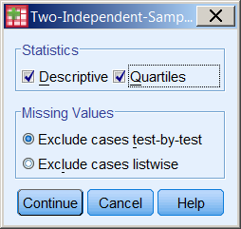

SPSS Output:

NPar Tests
Descriptive Statistics
 | N | Mean | Std. Deviation | Minimum | Maximum | Percentiles
 |  |  |  |  |  | 25th | 50th (Median) | 75th
scores | 27 | 6.2222 | 2.64842 | 1.70 | 11.90 | 4.2000 | 6.3000 | 7.7000
group | 27 | 1.37 | .492 | 1 | 2 | 1.00 | 1.00 | 2.00

Mann-Whitney Test
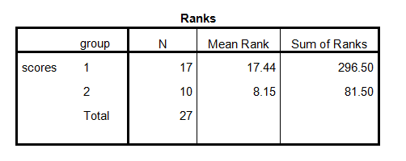
Test Statistics^{b}
 | scores
Mann-Whitney U | 26.500
Wilcoxon W | 81.500
Z | -2.938
Asymp. Sig. (2-tailed) | .003301
Exact Sig. [2*(1-tailed Sig.)] | .002159
a. Not corrected for ties.
b. Grouping Variable: group

Answers to the given questions:
- The probability level is .002159 which is less than less than .01 as well as .05.
- This allows me to reject the null hypothesis.

- Write-up:
As a researcher, I categorized the data into two groups experimental and control, inserted the data into SPSS, and run a non-parametric Mann-Whitney test. The Mann-Whitney U and Wilcoxon W tests result indicate a significant result (N = 27, z = 2.938, p <.01) that rejects the null hypothesis that the median scores of the two groups will not differ. In other words, the results indicate a z value of 2.938 that is greater than 2.56, the critical z value at an alpha level of .01. That indicates a significant difference among the median scores of the two groups. Again looking back the ranks result, the experimental group (group 1) has more mean rank (17.44) than the control group (group 1) (8.15). That means that the experimental group has better performance than the control group. That is, the new method is effective.

